CONAKRY (Guinea) | 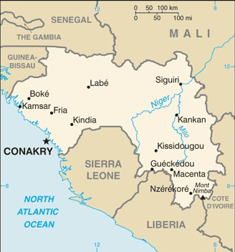  Taken from CIA World Fact Book
Population: 2.1 mil; Religion: Muslims 89%; Christians 7%;
Official language: French; Literacy 45,3%
DID YOU KNOW? Conakry is the capital of Guinea, a country in West Africa. The city sits on the slender Kaloum Peninsula, which extends into the Atlantic Ocean. It is home to 2,1 mil people, many of whom have come in from the countryside seeking work, exacerbating the strain on an already limited infrastructure. A port city, Conakry is the economic, financial & cultural centre of Guinea. With 25% of the world’s known bauxite reserves, as well as high-grade iron ore, significant diamond & gold deposits, & uranium, the country should have a robust economy. Unfortunately, political corruption & inefficient internal infrastructure have resulted in significant poverty. A military coup in 2021 deposed the democratically elected president. The Christian minority is strong by many standards but lacks Christian leaders. (Taken from 30 days of prayer for Ramadan)
Please pray :  - 43% of the population is under the age of 15. Pray that the message of hope through Jesus will be shared with these young people.  - For political & economic stability of this resource-rich nation.  - That leaders in the church will implement strong discipleship programs to develop additional leaders.  Don't go after false gods; they cannot help you or save you, ….  (1Sam 12:21) | SAAWE  Patrys 083 973 4011

DAKAR (Senegal) | 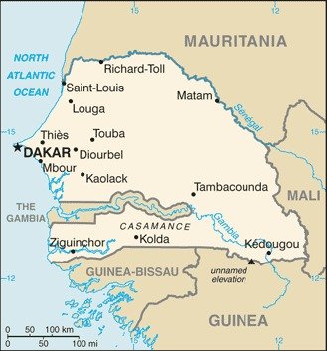  Taken from CIA World Fact Book
Population: 3,4 mil; Religion: Muslims 91%; Christians <5%; Official language: French; Literacy 55,4%
DID YOU KNOW? Dakar is the capital of Senegal, West Africa. It is a port city on the Atlantic Ocean. Colonized by the Portuguese in the 15th century, Dakar was one of the base cities for the Atlantic slave trade. With a vibrant economy driven by mining, construction, tourism, fishing & agriculture, Dakar is one of the more prosperous cities in West Africa. The country enjoys religious freedom & is tolerant of many faiths, but very few of the 91% Muslim majority have come to faith in Jesus, mainly due to the Muslim Sufi brotherhoods. These brotherhoods are organized, wealthy & have the political power, & more than 85% of all Muslims belong to one of them. Despite a relatively large Christian population spiritual oppression hovers over the city. Dakar is the key to evangelizing this nation. It is home to 25% of the nation’s population as well as members of every people group, making it possible to reach them with the Gospel. (Taken from 30 days of prayer for Ramadan)
Please pray :  - For the leaders of the current congregations to develop a vision for reaching the rest of the country.  - For breakthroughs into the tightly controlled Muslim brotherhoods in the city.  - That the teachers in private Christian schools, where most of the students are Muslim, will have an influence for Jesus on these young minds.  …. From every part of the world they will turn to him; (Ps 22:27) | SAAWE  Patrys 083 973 4011

SANA’A’ (Yemen) | 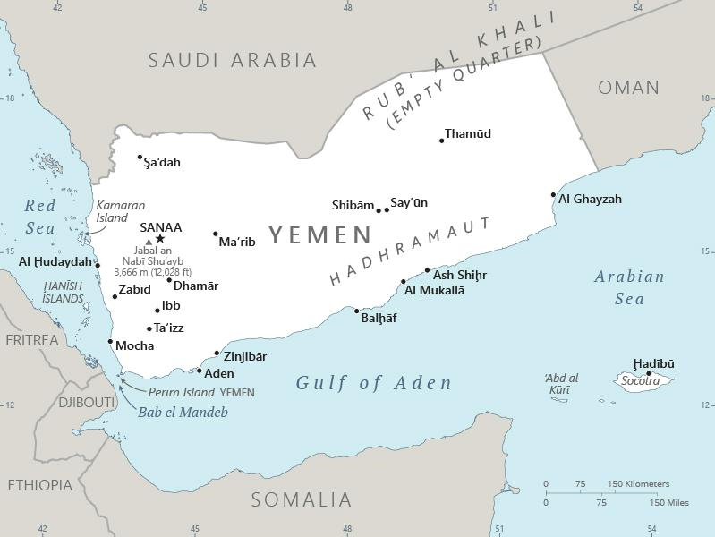  Taken from CIA World Fact Book
Population: 2,5 mil; Religion: Muslims 99,9%; Christians <1%; Official language: Arabic; Literacy 70,3%
DID YOU KNOW? For many centuries, Sana’a’, the capital of Yemen, has been the chief economic, political & religious centre of the country. The Old City is a UNESCO World Heritage Site. According to legend, Yemen was founded by Shem, one of the 3 sons of Noah. Today, Yemen is home to the world’s worst humanitarian crisis after a brutal civil war started six years ago. Since then over 4 mil people have fled their homes, & there have been 233 000 casualties from the war. Currently, Yemen has over 20 mil people who rely on some form of humanitarian aid for their survival. Less than 0,1% of the population is Christian. Believers meet secretly & only in small groups, facing dangerous opposition. Radio broadcasts of the message of Jesus, careful witness, & the dreams & visions of Muslim people are creating opportunities for the gospel in this war-torn land. (Taken from 30 days of prayer for Ramadan)
Please pray :  - For healing & restoration to come to this nation.  - For protection, wisdom & courage for the Gospel SURGE teams as they plant churches.  - For a mighty movement of prayer to sweep over Christians everywhere to lift up this war-torn city & nation.  See to it that no one takes you captive by philosophy and empty deceit,…. (Col 2:8 ESV) | SAAWE  Patrys 083 973 4011

OUAGADOUGOU (Burkina Faso) | 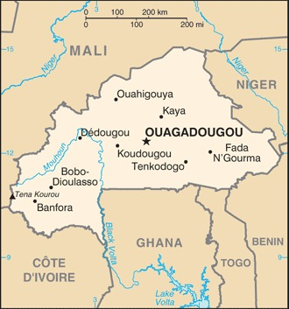  Taken from CIA World Fact Book
Population: 3,2 mil; Religion: Muslims 50%; Christians 20%; Official language: Mooré; Literacy 34,5%
DID YOU KNOW? Ouagadougou, or Wagadugu, is the capital of Burkina Faso & the administrative, communications, cultural & economic centre of the nation. It is also the country’s largest city. The city’s name is often shortened to Ouaga. The inhabitants are called “ouagalais”. The rise, or arrival from elsewhere, of radical jihadist Muslim groups has brought great turmoil to Burkina Faso. Both Christians & Muslims have been targeted & murdered by these Islamist groups. These attacks, combined with existing ethnic tensions, rebel groups, & political instability, led to not one but two military coups in 2022. On the surface, the population of Christians in the country would seem to be influential, with 20% of the people saying that they are Christian. However, the power of the spirit world has not been broken. Some say that the nation is 50% Muslim, 20% Christian, & 100% animist. The occult shows its power even in some churches. (Taken from 30 days of prayer for Ramadan)
Please pray:  - For the risen Christ to demonstrate His power & set people free from the occult.  - For the establishment of a stable & transparent government.  - For the teams in Ouagadougou sharing their faith in the true Jesus.  I revealed myself to those who did not ask for me: …(Is 65:1) | SAAWE  Patrys 083 973 4011

