KANO (Nigeria ) | 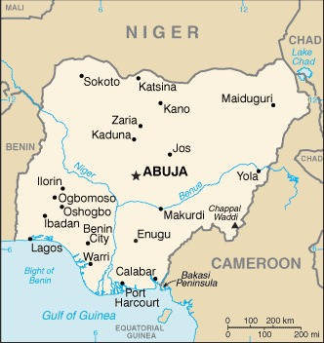  Taken from CIA World Fact Book
Population: >4 mil; Religion: Muslims 53,5% Christians 45,9%;
Official language: English; Literacy 77,6%
DID YOU KNOW? Kano is Nigeria’s most populous city, & the oldest in West Africa. It was founded at a junction of ancient Sahara trade routes, & today it’s the centre of a major agricultural region where cotton, & peanuts are grown & cattle are raised. Northern Nigeria has been Muslim since the 12th century. While the nation’s constitution allows for religious freedom, the reality is that non-Muslims are strongly persecuted in the north. During anti-Christian riots in May 2004 more than 200 people were killed & many churches & other buildings burned. More riots took place in 2012. To make matters worse Boko Haram leaders have vowed to take revenge on Christians. As a result, many Christian families have fled the area & moved to southern Nigeria. While the situation in the north seems dire, Nigeria is home to the 4th largest number of evangelicals in the world. (Taken from 30 days of prayer for Ramadan)
Please pray :  - Thank God for the tremendous growth of the Christian faith in Southern Nigeria.  - That Nigerian missionaries will return to the north bringing a message of peace through Jesus.  - The church in Nigeria is sometimes subject to prosperity gospel that distorts the real message of the Bible. Pray for biblical truth to be taught.  Don't go after false gods; they cannot help you or save you, ….  (1Sam 12:21) | SAAWE  Patrys 083 973 4011

BAMAKO (Mali) | 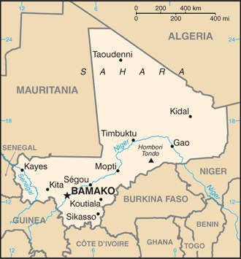  Taken from CIA World Fact Book
Population: 4,4 mil; Religion: Muslims 87%; Christians <2%; Official language: 11 languages; Literacy 48,2%
DID YOU KNOW? Mali is a landlocked country in the interior of West Africa. It is about the size of Texas & California combined & has a population of 22 mil. At one time Mali was a rich trading hub. Mansa Musa, Mali’s ruler in the 14th century, is considered to be the richest person in all of history with a worth in today’s dollars of 400 billion. In his lifetime, Mali’s gold deposits accounted for half the world’s supply. This is no longer the case. Roughly 10% of children will not survive to age five. Of those that do, one in 3 will be malnourished. 67% of the country’s land is desert or semi-desert. Islam in Mali tends to be more moderate & uniquely West African. The majority practice a faith that is a mixture of traditional African religions & superstitious folk practices. Bamako has more than 3 000 Quranic schools. (Taken from prayer for Ramadan)
Please pray :  - Less than 2% of the population are Christians. Pray for their safety as they share the love of Jesus with their Muslim neighbours.  - For the evangelization of the Bambara people, which would impact other tribes coming to Jesus.  - For Mali’s leaders for wisdom to deal with health, education & employment issues.  …. From every part of the world they will turn to him; (Ps 22:27) | SAAWE  Patrys 083 973 4011

MOGADISHU (Somalia) | 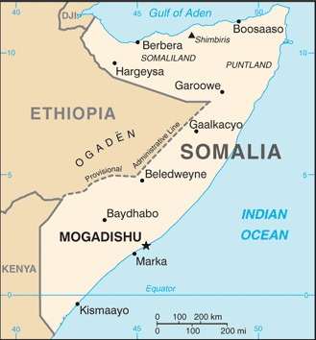  Taken from CIA World Fact Book
Population: 2,6 mil; Religion: Muslims 99,7%; Christians ±1000 people; Official language: Somali; Literacy 41%
DID YOU KNOW? Mogadishu, the capital city & the major port, is the largest metropolitan area in Somalia, located just north of the Equator on the Indian Ocean. Forty years of civil war & clan skirmishes have wreaked havoc on the nation & have further weakened tribal relationships, keeping the people of Somalia divided. For decades, Mogadishu has been a refuge for Islamic militants who target Jesus followers in Somalia & surrounding nations. Some modest level of stability may be finally at hand. There is a Parliament now, & the Al-Shabab terrorist group has left the city. However, they still hold influence in the rural areas, & true stability is still a way away. Somalia is overwhelmingly Muslim, 99,7% of the population. There is negative prejudice against Christianity that is a serious roadblock to growing a Jesus following presence. (Taken from 30 days of prayer for Ramadan)
Please pray :  - For supernatural wisdom, courage & protection for the Gospel SURGE teams as they risk all to plant churches.  - For a mighty movement of prayer to protect & cover Jesus followers.  - For the Kingdom of God to come in signs, wonders, & power over religious, government & university leaders.  See to it that no one takes you captive by philosophy and empty deceit,…. (Col 2:8 ESV) | SAAWE  Patrys 083 973 4011

KHARTOUM (Sudan) | 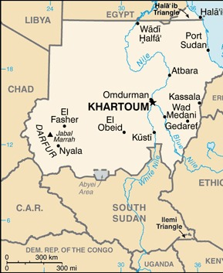  Taken from CIA World Fact Book
Population:6,3 mil; Religion: Muslims 91%; Christians 5,4%; Official language: Arabic & English; Literacy 60,7%
DID YOU KNOW? Khartoum, the capital of Sudan& is a large communications hub in Northeast Africa. It is a city located at the confluence of the Blue Nile & White Nile Rivers. Prior to the secession of the south in 2011, Sudan was the largest country in Africa. After decades of civil war, the country signed an agreement to separate the predominantly Christian south from the Muslim north, which had been seeking to become an Islamic state since the 1960’s. After years of war, the economy & infrastructure of the country & capital city are in disarray. With less than 2,5% evangelical Christians in the country, persecution is constant. The latest conflict in Sudan started in Apr 2023 & since then 15 000 have been killed & 8,2 mil displaced. Another source says 150 000 have already died. (Taken from 30 days of prayer for Ramadan)

Please pray:  - For a mighty movement of prayer to be started for Sudan.  - For multiplying house churches to be planted among the unreached people groups in Sudan.  - For leadership schools to be developed & for church planters to be sent out into every sector of society.  - For the Kingdom of God to come in signs, wonders & power.  I revealed myself to those who did not ask for me: …(Is 65:1) | SAAWE  Patrys 083 973 4011

