KARACHI (Pakistan) | 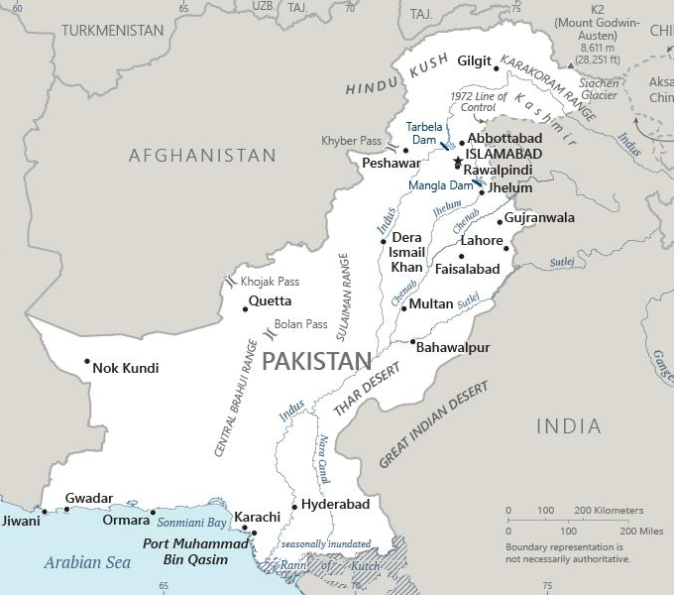  Taken from CIA World Fact Book
Population: 20 mil; Religion: Muslims 96%; Christians 2,5%;
Official language: Urdu & English; Literacy 58%
DID YOU KNOW? The 12th largest city in the world with over
20 mil citizens. Karachi is the former capital of Pakistan. It is located along the southern tip of the country, along the Arabian Sea coast. While it is no longer the capital city, Karachi remains the commercial & transport hub for the country & operates the largest port. In the 2022 Global Livability Index, the city ranked 168th out of the 172 cities, due to the high crime rate, poor air quality, & lack of infrastructure. 96% of the residents of Karachi identify as Muslim. Two-thirds of these are Sunnis, with the remaining Shi’ites, & the Christian population is just 2,5%. Religious minorities including Christians, Hindus, & minority Muslim groups face persecution. The “blasphemy laws” make insulting Mohammad punishable by death & damaging a Quran punishable by life in prison. Extremists use these laws to falsely accuse innocent people. (Taken from 30 days of prayer for Ramadan)
Please pray :  - For humble, committed spiritual leaders to disciple new believers.  - That believers will continue to share the gospel with Muslims in spite of severe false accusations & persecution.  - That the Holy Spirit will reveal the love of Jesus to thousands of residents of Karachi.  The Lord kills and brings to life:… (1 Sam 2:6) | SAAWE  Patrys 083 973 4011

KUALA LUMPUR (Malaysia) | 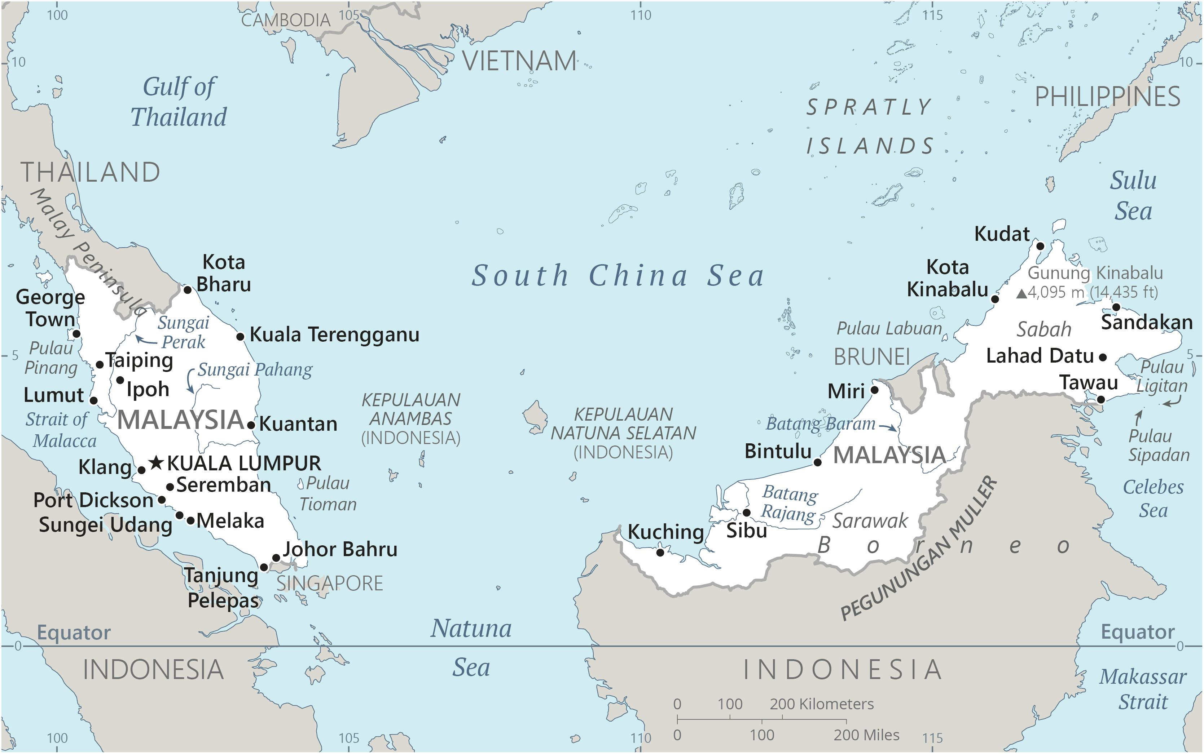  Taken from CIA World Fact Book
Population: 8,6 mil; Religion: Muslim 18,7%; Christians 6,1%;
Official language: Malay; Literacy 95,7%
DID YOU KNOW? Kuala Lumpur is the capital of Malaysia. It is well known for its modern skyline dominated by the 451-meter-tall Petronas Twin Towers with Islamic motifs. The people of Kuala Lumpur are diverse, with ethnic Malays making up the majority. Ethnic Chinese are the next largest group, followed by Indians, Sikhs, Eurasians, Europeans, & an increasing number of migrants. The religious mix in Kuala Lumpur is also diverse, with Muslim, Buddhist & Hindu communities living & practicing side by side. Approximately 9% of the population is Christian. Religious proselytization is allowed in Malaysia. In fact, many tourist-oriented hotels have a bible in their rooms.
Please pray :  - For the leaders, elected in 2022, to be successful in their efforts to satisfy both moderate & conservative Muslims, as well as the diverse minorities living in Kuala Lumpur.  - That believers will use the open opportunities to share the gospel with Muslims, Buddhists, Hindus & everyone else.  - That the many students in Kuala Lumpur will hear about Jesus & take the message back to their families.  …. From every part of the world they will turn to him; (Ps 22:27) | SAAWE  Patrys 083 973 4011

MASHHAD (Iran) | 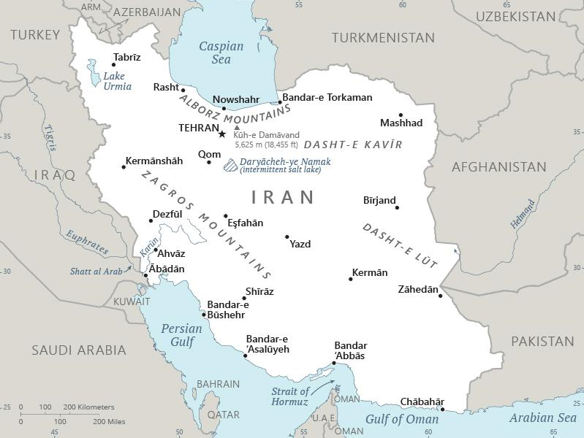  Taken from CIA World Fact Book
Population: 3,6 mil; Religion: Muslim 99,4%; Christians 0,3%; Official language: Farsi; Literacy 89%
DID YOU KNOW? Mashhad is a city of 3,6 mil people in northeast Iran. As the 2nd largest holy city in the world, Mashhad is a focus for religious pilgrimage for Muslims & was named as “Iran’s Spiritual Capital,” attracting more than 20 mil tourists & pilgrims annually. Many of these come to pay homage to the shrine of Imam Reza, the 8th Shi’ite Imam. Mashhad is also a centre of religious study for the country with 39 seminaries & numerous Islamic schools. Like the rest of Iran, Muslims in Mashhad practice Shi’ism, putting them at odds with most of their Arab neighbour states who are Sunnis. Differences in rituals & interpretations of Islamic law exist between the two. While the Iranian constitution recognizes 3 religious minorities, including Christians, persecution is frequent. Visibly carrying a bible is punishable by death & there are stern laws against printing & importing bibles in the Farsi language.
Please pray :  - For Iranian women who are protesting the oppression of the regime.  - That leaders of the underground church will be sensitive to the leading of the Holy Spirit as they seek to share their faith.  - That the nomadic people in the Zagros Mountains will be receptive to the gospel being brought to them by outreach teams.  …..he has put eternity into man's heart,…. (Ecc 3:11) | SAAWE  Patrys 083 973 4011

MECCA (Saudi Arabia) | 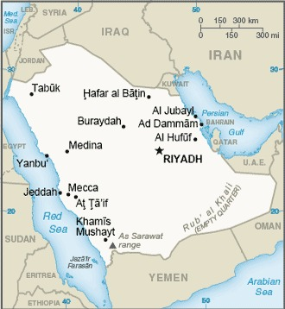  Taken from CIA World Fact Book
Population: 1,6 mil
Religion: Muslims 100%;
Official language: Arabic; Literacy 97,6%
DID YOU KNOW?
Mecca, the birthplace of Islam, & the religious centre to which hundreds of millions of Muslims turn towards daily in prayer, is the holiest city in Islam. Only Muslims are allowed in the city, with millions arriving for the annual Hajj (pilgrimage). Dating from the seventh century, the central Masjid al-Haram (Sacred Mosque) surrounds the Kaaba, the cloth-covered cubic structure that is Islam’s most sacred shrine. Islam originated approximately 1400 years ago in the nation of Saudi Arabia when the founder, Muhammad, declared that no other religion should exist on the Arabian Peninsula. This is still the official doctrine today & no other religion s can be practiced openly. There is some level of tolerance for non-Muslim private religious practices.
Please pray:  - For a mighty movement of prayer to rise up from the nations of the earth for this great city.  - For an outbreak of revelation & angelic visitations in this city.  - That many Saudis will come to know & follow Jesus.  I revealed myself to those who did not ask for me: I was found by those who did not seek me….. (Is 65:1) | SAAWE  Patrys 083 973 4011

