CHITTAGONG (Bangladesh) | 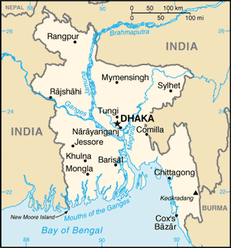  Taken from CIA World Fact Book
Population: 9 mil; Religion: Muslims 89% Christians 0,6%;
Official language: Bengali; Literacy 75%
DID YOU KNOW? Chittagong is a large city on the southeastern coast of Bangladesh. It is the second largest city in the country. Adherents to Islam comprise 89% of the population. Most of the remaining people practice a variation of Hinduism, with Christians accounting for just 0,6%. The Bengali people are the largest unreached people group in the world & are the majority population in Chittagong. Most practice a style of folk Islam that combines Sufi Islam, indigenous cultures & Hinduism. Very few have heard the true gospel. The cycle of poverty in Bangladesh continues to be a serious problem. While most of the monsoon flooding occurs further to the north, many of the people of Chittagong continue to live below the flood line. The overpopulation of Bangladesh is significant. With few natural resources & a political climate that offers little hope, Chittagong is a city with a desperate need for the message of Jesus. (Taken from 30 days of prayer for Ramadan)
Please pray :  - For trained godly leadership for the church in Chittagong & all of Bangladesh.  - For teams from near cultures who risk their lives to share Jesus with the people of Chittagong.  - That more & more Bangladeshis will accept Jesus as Saviour.  Don't go after false gods; they cannot help you or save you, ….  (1Sam 12:21) | SAAWE  Patrys 083 973 4011

ANKARA (Turkey) | 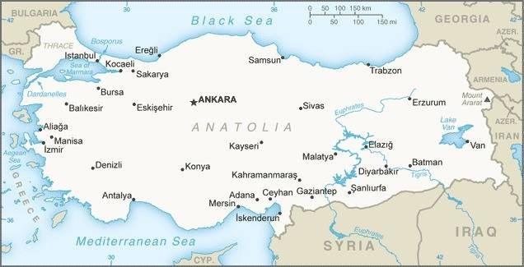  Taken from CIA World Fact Book
Population: 5,7 mil; Religion: Muslims 90%; Christians+others 0,2%; Official language: Turkish; Literacy 96,7%
DID YOU KNOW? Turkey’s cosmopolitan capital sits in the central part of the country, roughly 280 miles southeast of Istanbul. It is a city with a unique blend of ancient & modern architecture. Old castles & ruins from the Hittite, Roman, & Ottoman empires dot the landscape. Adjacent to them are modern government buildings, theatres, major universities, consulates, & bustling night life. Turkey is geographically located as a hinge between Europe & Asia, & its citizenry reflects this diversity. While Turkish is the official language, there are numerous people groups & more than 30 unique languages spoken in Ankara. Among these are Kurdish, Zazaki & Arabic. There is renewed interest in international trade & economic support for the nation. The opportunity to interact & share the gospel with the diverse population has never been better. (Taken from 30 days of prayer for Ramadan)
Please pray :  - For God to open his people’s eyes to see the Muslim world through his eyes.  - For believers in Ankara to be sensitive to when people’s hearts are ready to receive the message of Jesus.  - For believers sharing the gospel in Ankara to stand strong in spite of hardships, stress & persecution.  …. From every part of the world they will turn to him; (Ps 22:27) | SAAWE  Patrys 083 973 4011

BAGHDAD (Iraq) | 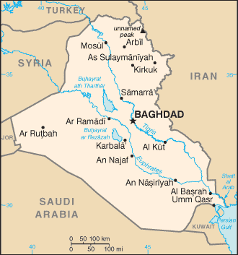  Taken from CIA World Fact Book
Population: 7,7 mil
Religion: Muslims 95-98%;
Official language: Arabic; Literacy 85,6%
DID YOU KNOW? Baghdad, formerly named “City of Peace,” is the capital of Iraq & one of the largest urban agglomerations in the Middle East. In fact, with 7,7mil people, it is second in population only to Cairo in the Arab world. When Iraq was at the height of its stability & economic stature in the 70’s, Baghdad was revered by Muslim as the cosmopolitan centre of the Arab world. After enduring seemingly constant war & conflict over the past 50 yrs, this emblem feels like a fading memory to its people. Today, most of Iraq’s traditional Christian minority groups can be found in Baghdad, numbering around 250 000 people. With unprecedented population growth & continued economic instability, a window of opportunity is opened for Jesus followers in Iraq to heal their fractured nation through the peace of God found only in the Messiah. (Taken from 30 days of prayer for Ramadan)
Please pray :  - For multiplying house churches to launch gospel movements among the Iraqi & North Iraqi Arabs & Northern Kurds.  - For the historic church to be filled with God’s grace & boldness to share their faith with others.  - For the Kingdom of God to advance through prayer & evangelism.  See to it that no one takes you captive by philosophy and empty deceit,…. (Col 2:8 ESV) | SAAWE  Patrys 083 973 4011

JERUSALEM (Israel) | 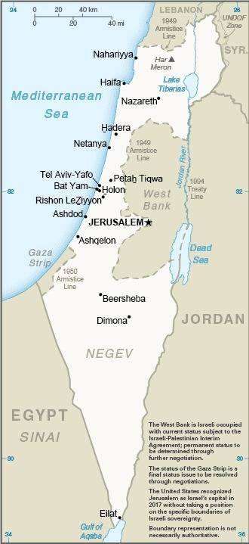  Taken from CIA World Fact Book
Population: 874 186; Religion: Jewish 60%; Muslims 37,2%; Christians 1,7%; Official language: Hebrew; Literacy 97,8%
DID YOU KNOW? Jerusalem, a holy site of pilgrimage for the three Abrahamic faiths of Judaism, Christianity & Islam, is a hotbed for religious & ethnic conflict, as well as geopolitical positioning. Jews are seen pressing up against the Wailing Wall in anticipation of the coming Messiah who will rebuild the Temple. Meanwhile, Muslims visit the site where they believe Muhammad ascended to heaven & was given requirements for prayer & pilgrimage. Simultaneously, Christians are found touring the sites of Jesus’ life, death, & resurrection. Jerusalem has much to attract tourists, & an average of over three million people visit the city each year. The region has struggled to attain peace due to deep cultural & political rifts that have divided Israel from their neighboring countries. Add into the mix a rich diversity & 39 languages, & the stage is set for a movement of God. (Taken from 30 days of prayer for Ramadan)
Please pray:  - For peace among all ethnic groups, languages, & peoples through the declaration of Jesus the Messiah.  - That the eyes of the Jews will be opened to recognize Jesus as the Messiah they are waiting for.  - For the Kingdom of God to come in signs, wonders & power.  I revealed myself to those who did not ask for me: …(Is 65:1) | SAAWE  Patrys 083 973 4011

