MADAGASCAR– Colonised by France (1894 -1960) | 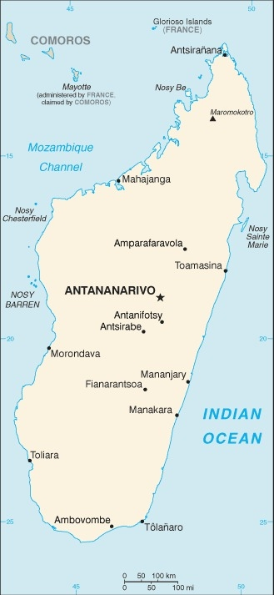  Taken from CIA World Fact Book
Population: 29,2mil
Religion: Tribal beliefs 52%; Christians 41%; Muslims 7%; Official language: Malagasy & French; Literacy 77.48%
DID YOU KNOW? Madagascar is the world’s 4th largest island. From the 17th to 19th century thousands of Madagascar’s people were taken to American port as slaves. This island was colonized by the French in 1894. In 1947 an estimated 90 000 people were killed during the Malagasy Uprising, a rebellion against the colonial rule by nationalists which was crushed by the French government. In 1960 Madagascar gained independence. 17 yrs of single-party rule & 3 coups followed. In 2014 it returned to constitutional order. Madagascar is a resource rich country, although the shortage of infrastructure has kept them from using it to their benefit. Roughly 70% of the Malagasy live on less than 1$ per day. In the early 1800s Madagascar was ruled by King Ramavo, the first to let Christians on the Island, which made him many enemies among those with strong beliefs in their traditional way of life. His wife, who ruled after his death, expelled all Christians. King Radama II opened the island to trade & welcomed missionaries back.
Please pray :  - For healing of the wounds caused by slavery & colonialism.  - For honest government leaders with a vision to bring their country to financial & political stability.  - For well-trained Christian workers willing to serve in isolated areas.  … He loves even the strangers living among us. (Deut 10:18 ERV) | SAAWE  Patrys 083 973 4011

MAURITIUS – Colonised by Holland, France & Britain (1598-1968) | 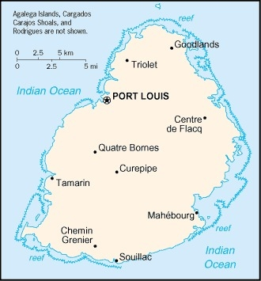  Taken from CIA World Fact Book
Population: 1,3 mil
Religion: Hindus 49%; Christians 26%; Muslims 17%
Official language: French& English; Literacy 92,2%
DID YOU KNOW? Mauritius is known as a honeymooner’s paradise. But Mauritian history is soaked in stories of immigration, subjuga-tion, slavery, exploitation & indenture, & it is a story of human perseverance & triumph. It gained its independence in 1968. Indentured labourers were brought from Madagascar, India, south-east Asia, East Africa & China. Approximately 70% of modern Mauritians are descendants of these indentured labourers. This nation has one of the highest per capita incomes on the continent. Christianity came to Mauritius with the Dutch in 1598. The French brought Christianity again when they arrived in 1715. It has the highest rate of opiate use (drugs made from poppies) in Africa.
Please pray :  - For healing of the wounds caused by slavery & colonialism.  - That the church will reach out to those in bondage of drugs. Pray that they will be set free & be healed.  - That God will reveal himself to the unreached peoples of Mauritius.  …. From every part of the world they will turn to him; (Ps 22:27) | SAAWE  Patrys 083 973 4011

ESWATINI – Colonised by Britain (1871-1968) | 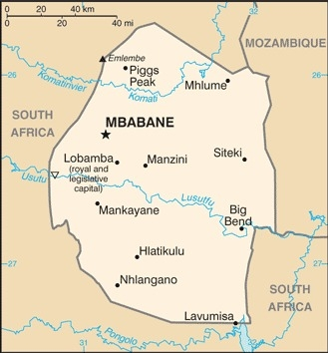  Taken from CIA World Fact Book
Population: 1,1 mil; Religion: Christians 90%; Muslim 2%;
Official language: Swati & English; Literacy 89,3%
DID YOU KNOW? The Swazi’s supplied slaves both to the South African ‘Boers’ & to the Portuguese in Mozambique. Swaziland was a British protectorate from 1871 until its independence in1968. Eswatini is one of Africa’s smallest nations. Since 1996, the nation has had growing political unrest due to the monarchy & its ban on political parties. It is commonly known that King Sobuza I had a dream in which he saw strange people with white skin coming into his country with a book (Bible) in the one hand & other people with gold coins. The King sent a delegation to missionaries to invite them to come to the Land of the Swati & teach the people this message. In 1844, the Methodist Church built its 1st mission in Eswatini. Although the population is roughly 90% Christian, churches compromise regarding polygamy, witchcraft, ancestor veneration & appeasement sacrifices. This has opened the door for sins such a sexual impurity to take root, contributing to the widespread devastation of HIV/AIDS – the infection rate is one of the highest in the world.
Please pray :  - For healing of the wounds caused by slavery & colonialism.  - That all churches will address the physical, emotion & spiritual needs of AIDS sufferers & their families.  - For those bound by ancestor worship & the occult to find freedom in Jesus Christ.  …..he has put eternity into man's heart,…. (Ecc 3:11) | SAAWE  Patrys 083 973 4011

LESOTHO– Colonised by Britain (1868-1966) | 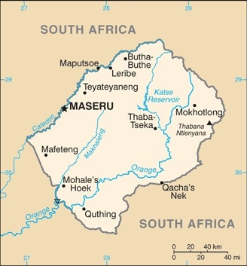  Taken from CIA World Fact Book
Population: 2,1 mil; Religion: Christians 89%;
Official language: Sotho & English; Literacy 82%
DID YOU KNOW? Lesotho was originally inhabited by various Khoisan groups. Sotho societies arrived in Basutoland in the 17th century. King Moshoeshoe I united the Sotho tribes against Zulu invaders. In 1834 large numbers of Trekboers began to settle on the western boarders of the kingdom & began to challenge the right of the Sotho to their land. The next 30 years were characterized by conflict & outbursts of war between the Sotho & the Boers. In the late 1860s Moshoeshoe appealed to the British for assistance. The governor of the Cape Colony annexed the kingdom in 1868. The British did little to develop the country. It became a labour reserve for the farmers of the Orange Free State & the gold mines of the Witwatersrand. It gained independence in 1966. Lesotho faces great challenges. The HIV infection rate is among the highest in the world. Other challenges are: family breakdown, poverty, unemployment & limited access to water.
Please pray:  - For healing of the wounds caused by slavery & colonialism.  - For believers working in HIV/AIDS related ministries to spread hope through Christ.  - That the Lord will provide for the poor & restore families.  …. I was found by those who did not seek me….. (Is 65:1) | SAAWE  Patrys 083 973 4011

